

System Requirement Specification
Smart Drawer

Version  Status  Date | 1.0  Issue  11-February-2017

Confidentiality Notice
Copyright (c) 2026 eInfochips. - All rights reserved
This document is authored by eInfochips and is eInfochips intellectual property, including the copyrights in all countries in the world. This document is provided under a license to use only with all other rights, including ownership rights, being retained by eInfochips. This file may not be distributed, copied, or reproduced in any manner, electronic or otherwise, without the express written consent of eInfochips.

Contents

1 Document Details 3
1.1 Revision & Approval History 3
1.2 Definition, Acronyms and Abbreviations 3
2 introduction 4
2.1 Purpose of the Document 4
2.2 Intended Audience 4
3 system overview 4
3.1 Overview 4
3.2 Scope 6
3.2 Usecase Diagram 6

4 functional RequiREment 5
4.1 Insert rfid tags in tag banck 5
4.1 Mapping rfid tags with items/person 6
4.1 Item/person in 6
4.1 Item/person out 6
4.1 View items in drawer 7
5 NON-functional RequiREment 7
6 External Interface 8
6.1 User Interface 9
6.2 Hardware Interface 8
6.3 Software Interface 8

Document Details

Revision & Approval History
Version | Author |  | Reviewer |  | Approver
Version | Name | Date  (DD-MM-YYYY) | Name | Date  (DD-MMM-YYYY) | Name | Date  (DD-MM-YYYY)
Issue 1.0 | Dhyan Patel  Krisha Jain  Zarna Pansuriya | 10-Feb-17 | Dhyan Patel | 10-Feb-17 | Saurabh Soni  Darshana Mistry | 11-Feb-17

Definition, Acronyms and Abbreviations

Definition/Acronym/Abbreviation | Description
Smart Drawer | Smart Drawer is one product which can be useful in inventory management which keep track of item in-out with respective person.
RFID | Radio Frequency Identification
Transaction | In/Out activity done by RFID reader.
InLog | It is the auto generated log when item goes in.
OutLog | It is the auto generated log when item goes out.

introduction

Purpose of the Document
- The purpose of this document is to give a detailed description of the requirements for the "Smart Drawer". It will illustrate the purpose and complete requirement for the system. It will also explain system constraints, interface and interactions with other external applications. This document is primarily intended to be submitted to a customer for its approval as a reference for developing the first version of the system for the development team.
- There is no efficient tracking, monitoring and security solutions for the protections of products. Because of this project, we can track and monitor our products

Intended Audience
- The intended audience of this document includes the client, requirements team, requirements analyst, design team, testers, and other members of the developing organization to provide guidance.

system overview

Overview
    - Product Perspective
- Smart Drawer is used for tracking and monitoring Product in the inventories. It helps managers to easily handle the whole inventory.
- It also helps to identify the person who put/took item in/from drawer.

    - Purpose & description
- When the products are take out from drawer it will be automatically scan by RFID reader. It will read the RFID tags of products. Scanned products had their product id will be automatically stored in the system with respective person details.
- When the manager open a web portal, after login use admin. In this panel there are all the detail of product will be show to them like how many items are in the drawer.

3.1.3 Objective
- To develop a module using RFID tag and RFID reader which is used to tracking and monitoring the products.
- Web panel will be provided to the manager to manage all details of products.

Use Case Diagram

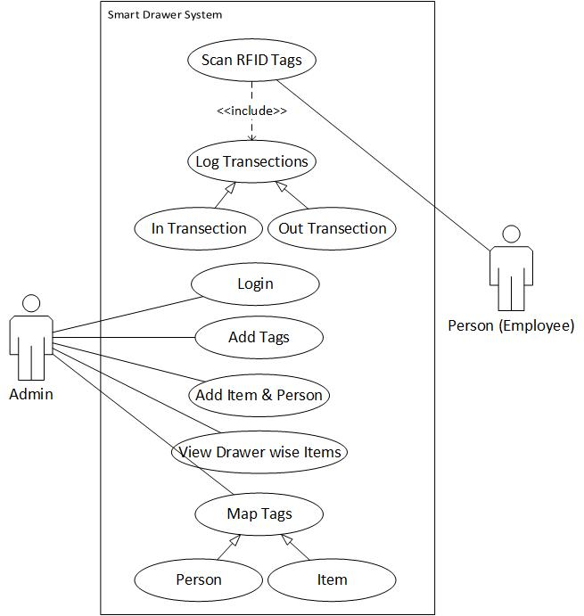

Scope
- Admin Side:-
  - Admin side include the functionalities like insert RFID tags, mapping with item/person and inventory management.
  - Inventory management include functionalities like check item details in specific drawer and check in/out transaction details.
  - Transaction details includes item details, timestamp and respective person of that transection.

- Reader Side:-
  - Reader side has the main feature of taking data by scanning RFID tag and log in to the system. Log can be elaborate more by InLog and OutLog.

F UNCTIONAL REQUIREMENTS

- Insert RFID tags In Tag Bank.
- Mapping RFID tags with Items/Persons.
- Items/persons In.
- Items/persons Out.
- View Items in Drawer.

Insert RFID tags In Tag Bank

Term | Description
REQ ID | RQ01
Purpose | Store unique RFID tags into Tag Bank.
Access Restrictions | Authorized Person
Input(s) | RFID Tags
Output(s) | Information
Process | - Provide/Insert RFID tags.

4.2 Mapping RFID tags with Items/Persons.

Term | Description
REQ ID | RQ02
Purpose | Mapping of RFID TAG
Access Restrictions | Authorized Person
Input(s) | Select RFID Tag
Output(s) | Information
Process | - Insert tag category of the tag.  - Mapping RFID tag with appropriate item or person  (Depends on tag category).

4.3 Items/persons In.

Term | Description
REQ ID | RQ03
Purpose | Give an information about added item to the drawer
Access Restrictions | Tag holder Person
Input(s) | Add item to the drawer
Output(s) | Information
Process | - RFID tags will be scan by RFID reader.  - RFID reader gives item id.  - Mapped item is added to the drawer.

4.4 Items/persons Out.

Term | Description
REQ ID | RQ04
Purpose | Give an information about removed item from the drawer.
Access Restrictions | Tag holder Person
Input(s) | Remove from the drawer
Output(s) | Information
Process | - RFID tags will be scan by RFID reader.  - RFID reader gives item id.  - Mapped item is remove from the drawer.

4.5 View Items in Drawer.

Term | Description
REQ ID | RQ05
Purpose | Give an information about available item in the drawer.
Access Restrictions | Authorized Person
Input(s)
Output(s) | Information
Process | - Request for viewing the items.

Non-functional requirements

Reliability
- The application should be highly reliable and it should generate all the updated information in correct order.

Availability
- Any information about the product should be quickly available to the authorized user 24/7.

Security
- The system must be fully accessible to only authentic users.

External Interface

User Interface
All user interfacing is done through a web UI

- Login interface to enter in the system.
- Add Tags interface to add tags into the tag bank.
- Add Interface to add item and person.
- Mapping interface to map tag with item/person.
- View Items interface to check available items in specific drawer.
- View Transaction interface to check transactions.

Hardware Interface
- RFID Reader
- RFID Tag
- Computer
- RAM(free) : 500 MB

Software Interface

As this system is controlled through computer/mobile, it will require following software interface.

Name of Software | Use of Software
Web Browser | To access web application(system)

